Accessing your roster from computer
Login to Demosphere. Go to Teams under Demosphere Universal Experience
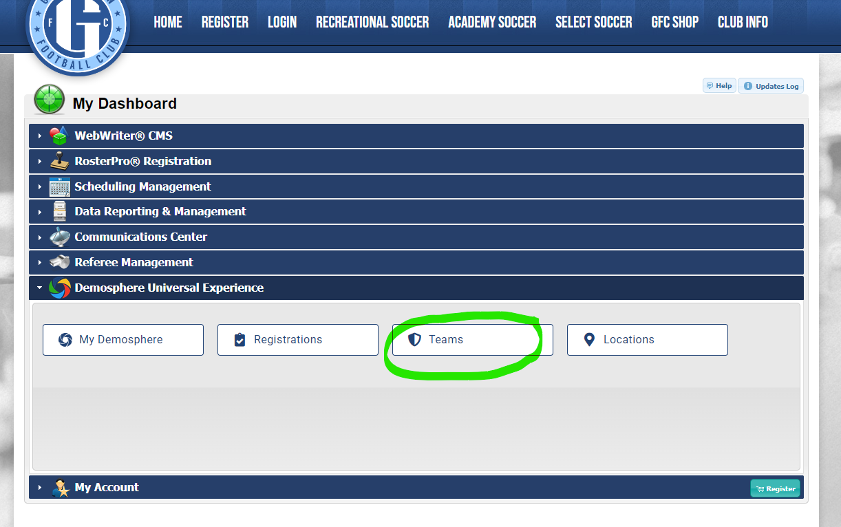
Or, if you don’t have that section go to My Account – My Teams
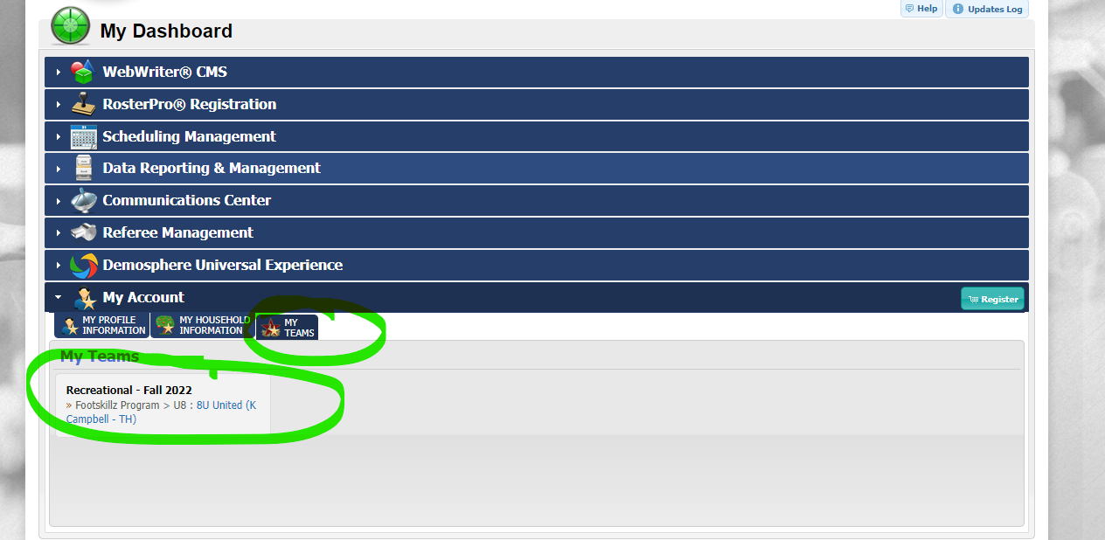

Click on the team name that you are coaching. Your practice day is part of the name (TH for Thursday in this example). You can see the names of your players in the ROSTERED PLAYERS section highlighted in blue. If you want to print or view a full contact list go to the three dots in the top right (highlighted green). Click that and select printer icon. It will give you an option to print, save a PDF or export a csv.
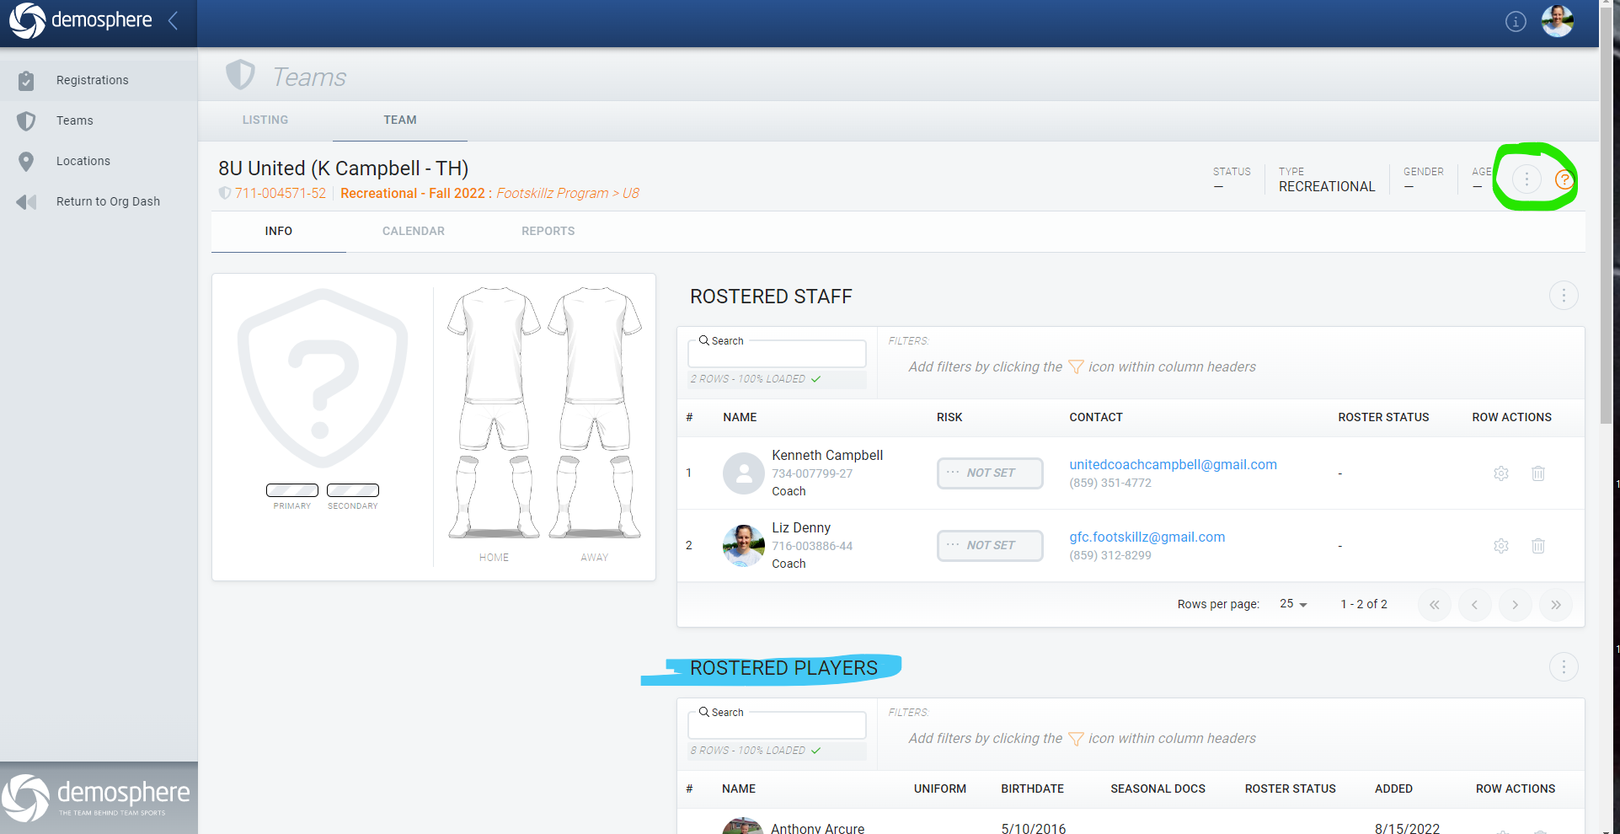
Below is what you’ll get with Save PDF function. It will list all players and the parent 1 and 2 contact information that they have loaded to the system. Some kids will only have 1 parent listed in the system.
